„Financial support to Priority Area Coordinators: DTP 2nd PAC Call: DTP-PAC2-PA6“

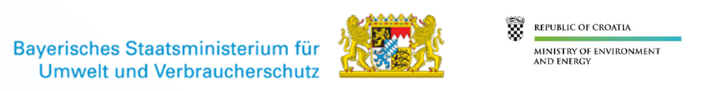

Under the Specific Objective 4.2. „Support to the governance and implementation of the EUSDR“ of the Danube Transnational Programme (DTP), the PACs of the Priority area 6 (PA 06) were granted co-financing for the project: „Priority Area 06: Biodiversity, Landscapes, Air and Soils“ - DTP-PAC2-PA6.
Lead Partner is Bavarian State Ministry of the Environment and Consumer Protection and Project Partner is Ministry of Environment and Energy of the Republic of Croatia, both acting as Priority Area Coordinators (PACs) for PA 06.

The Project shall continue to support the implementation of Priority Area 06 of the EU Strategy for the Danube Region, adapted to current needs and challenges ahead. The revised EUSDR Action Plan will provide the newly defined objectives and actions to be tackled in the project lifetime. Beside the content-oriented work, the connection to the policy level shall be further strengthened. The expected change from the implementation of this project is an improved coordination and implementation of the Strategy in PA 06, as well as a high political momentum for the topics PA 06 is dealing with.
Specifically, the Project aims at sound management procedures for implementing PA 06 objectives, thus support the PACs work to coordinate and manage the implementation process, including cooperation with relevant EUSDR actors, other PA's and the Steering Group. Furthermore, it shall contribute to facilitate effective work of stakeholders connected to PA 06 issues, such as the PA 06 Task Forces, raise awareness of the policy level and the wider public accordingly and gain in-depth knowledge on specific topics. Overall, the project shall contribute particularly to systematically network various stakeholders in the Danube Region with the policy level in the EUSDR states.
The Project DTP-PAC2-PA6 is co-financed by the Interreg Danube Transnational Programme, with total support of 238.068,00 EUR from the European Regional Development Fund (ERDF). The project start was on 1. January 2020 and will last until 31. December 2022.

